**App Name:** GameBook

**Task:** “Select Favorit Team game”, “View game players” and “View team game score”

**Student Name (Expert):** Edgar Caruço

**Nielsen Heuristic:** H1. Visibility of system status

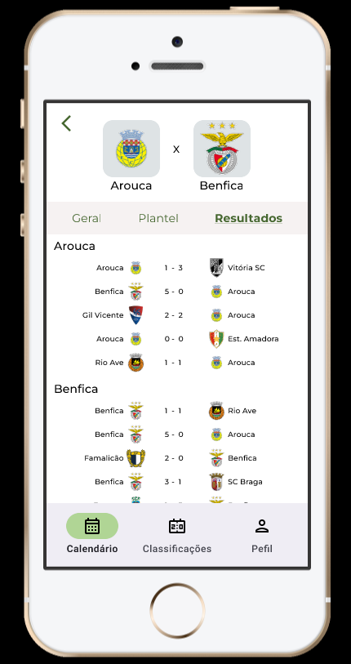

**Problem:** Calendar is always selected

**Heuristic:** H1. Visibility of system status

**Description:** The system should always indicate were the users are “Resultados” is fine but “Calendar” should not be selected (the present information is not related to “Calendar”)

**Correction:** Remove the selection from “Calendar” when not on Calendar

**Severity:** 3 - Important usability problem